Introduction to Embryonic Diapause: Pregnancy in Waiting: Proceedings of the Third International Symposium on Embryonic Diapause

BD Murphy¹, K Jewgenow², MB Renfree³, SE Ulbrich⁴
¹Centre de recherche en reproduction et fertilité, Université de Montréal, Canada
²Leibniz-Institute for Zoo and Wildlife Research, Berlin, Germany
³School of BioSciences, University of Melbourne, Australia
⁴Institute of Agricultural Sciences, ETH Zurich, Switzerland

The capacity of the mammalian embryo to arrest development during early gestation is a topic that has fascinated biologists for over 150 years. The first known observation of this phenomenon was in a ruminant, the roe deer (Capreolus capreolus) in 1854, later confirmed in a number of studies in the last century [1]. The phenomenon, now known as embryonic diapause, was then discovered to be present in a wide range of species and across multiple taxa. Since that time, its biological mystery has attracted studies by scientists from around the globe.
The First International Symposium on the topic of embryonic diapause in mammals was held in 1963 at Rice University, Houston, Texas. It resulted in a proceedings volume entitled “Delayed Implantation”, edited by A.C. Enders [2]. The symposium was distinguished novel recognition of that era that a wide range of species had been identified with embryonic diapause, including some marsupials and carnivores. The emerging technology of the time, particularly structural approaches, permitted new understanding of the events of diapause and embryo reactivation. The newest methods provided key data on the temporal window of implantation in rodents, introduced new physiological approaches, and illustrated some of the first transmission electron microscope investigations of the blastocyst.
The Second International Symposium on Embryonic Diapause was held in Thredbo, Australia in 1980. The proceedings entitled “Embryonic Diapause in Mammals”, edited by A.P.F. Flint, B.J. Weir and M.B. Renfree [3] were published as Supplement 29 of the Journal of Reproduction and Fertility in 1981. As with the previous meeting, the diversity of species displaying diapause was highlighted. The research contributions specifically exploited maturing technology to study reproductive processes, particularly the capacity to accurately measure hormones and the advances in imaging. Among the highlights of that meeting were studies that reported the essential role of prolactin as a negative regulator on the one hand. maintaining diapause in marsupials [4] and, on the other, as a positive activator, terminating diapause in a carnivore species [5].
Some 39 years had passed since the last symposium on the topic of diapause, and the impetus for convening a new congress on the subject came from a meeting between the current organizers in 2017. After some discussion and a number of Skype conferences across three continents, it was agreed that the meeting would be organized in Switzerland at ETH Zurich. A joint application for funding to hold the Symposium at Congressi Stefano Franscini, Monte Verità, Ascona Switzerland was successful, and funding was acquired from ETH Zurich, the Swiss National Science Foundation and additionally, from the Society for Reproduction and Fertility. Again, the Symposium was truly interdisciplinary as well as international, in that it from four continents and from universities, research institutes, zoos and industrial settings. We also wished to acknowledge the major contributions over the last 50 years of three pioneers in research on embryonic diapause, namely, Drs. Allen Enders, Rodney Mead and S.K. Dey (Figure 1), so we invited each of them to provide a short video recording. Their research insights into this enigma of diapause provided a wonderful introduction to the meeting. Their videos can be found at the following link: https://www.diapause2019.ethz.ch/abstract-submission/é

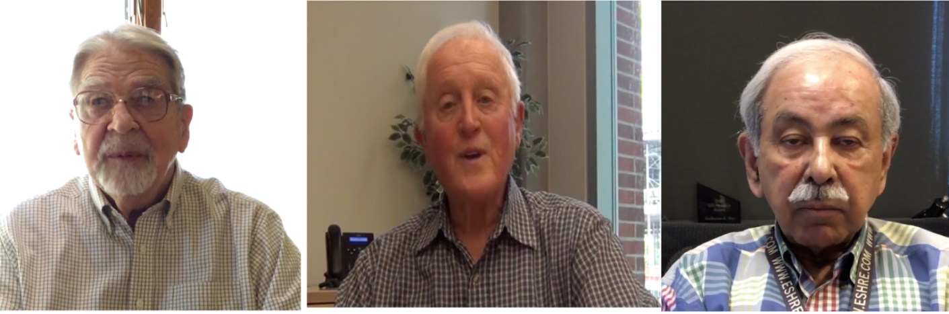
Figure 1. Pioneers in the study of embryonic diapause. Left to right: Allen C. Enders, Rodney A. Mead and Sudhansu K. Dey.

Much has changed in research since 1980, and a wealth of new information has become available about embryonic diapause from laboratories all over the globe, in a number of unrelated species and from multiple perspectives. The overall goal of the Third Symposium was to provide a 21st century perspective on the events and regulation of diapause. The meeting successfully brought together scientists from multiple disciplines and with a variety of interests, including bench and field biologists, exotic species specialists, cell biologists and stem cell researchers, highlighting the new molecular techniques now available (Figure 2, see appendix for contact information). Among the specific goals of the Symposium was to focus on understanding the structural and molecular changes that take place in the embryo upon entry into its arrested state, on how it is maintained with little or no progression during diapause, as well as the mechanisms and sequelae of its reactivation. As the uterine environment represents the proximal control of diapause, a further specific aim was to acquire an up-to-date panorama of uterine regulatory mechanisms that promote developmental arrest and subsequent reactivation of the embryo. We now know that there are remarkable commonalities in the mechanisms of control of diapause among the three best studies species, the mouse, the mink and the tammar wallaby [6-8]. Thus, it was the intention that by close examination of a diverse range species with diapause, light could be shed on the evolution of the trait, whether it evolved once, or whether its presence in unrelated taxa demonstrates parallel or convergent evolution of this important strategy. Finally, as the first embryonic stem cells were derived from the inner cell mass of rodent embryos in diapause, gaining insights into stem cell pluripotency and differentiation was a significant goal of the Symposium.
A further important aim of the symposium was to pass the baton to the new generation of researchers studying diapause. In this context, three young investigators were invited as the keynote speakers, representing state-of-the-art research in rodent, marsupial and carnivore diapause. As with previous symposia, species diversity was an important topic, with presentations on topics that ranged from seals to wolverines and bats. The presence and characterization of diapause in endangered species, particularly the giant panda, were topics of presentation and discussion. To unravel the mysteries of diapause, the traditional approaches of structural, cell culture, hormonal quantification and imaging technology were complemented by state-of-the-art molecular methods, ranging from global transcriptome and proteome analysis to in situ hybridization and in-depth lipid and carbohydrate analyses.
The Congressi Stefano Franscini sponsored two prizes for the best presentations by a young scientist. Michelle Shero received the presentation prize for her study on seals and the best poster prize was shared by Vera van der Weijden for her work in roe deer and Lukasz Gasior for his poster on transcriptomics of mouse embryos in diapause.
From the 35 abstracts of oral and poster contributions (Appendix B) to the symposium, some 15 manuscripts were submitted for inclusion in this volume of the proceedings. Some who presented preliminary and primary data chose not to submit, and some presentations on the same topic or species were consolidated into a single manuscript. All manuscripts were subject to peer review for content, quality and originality. The edited versions of the discussion of the presentations, where manuscripts were submitted, follow each article.

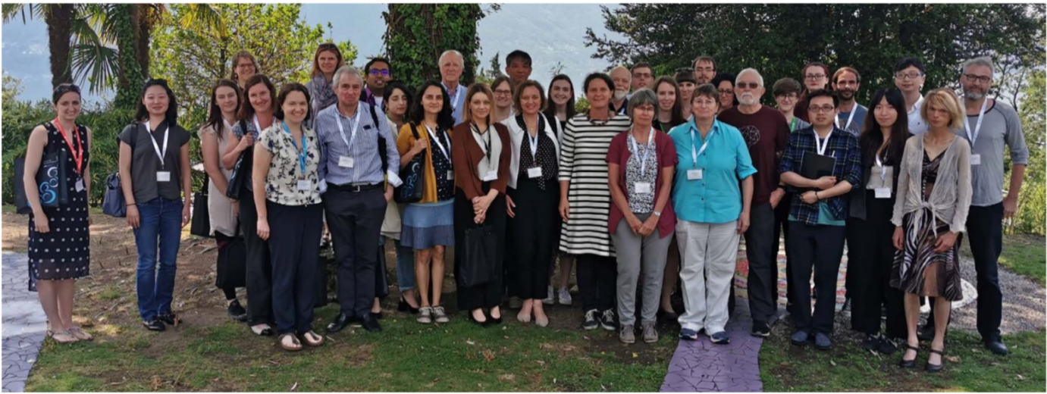
Figure 2. Attendees at the III International Symposium on Embryonic Diapause. From left to right: Michelle Shero, JeeYeon Cha, Jessye Wojtusik, Anna Rüegg, Erin Curry, Jane Fenelon, Helen Bateman-Jackson, Chris Murphy, Arnab Banerjee, Simona Bisogno, Aydan Karslioglu, John Rasweiler, Roberta Arena, Jella Wauters, Toshihiko Fujimori, Grazyna Ptak, Kirsten Wilson, Susanne Ulbrich, Hans-Werner Denker, Lukasz Gasior, Katarina Jewgenow, Anna Hankele, Joanna Rudnicka, Szymon Gawel, Marilyn Renfree, Federica Zacchini, Bruce Murphy, Vera van der Weijden, An Junhui, Kinga Fic, Sergio Ruiz Macias, Yisi Hu, Cai Kailai, Barbara Drews, Stephen Frankenberg. Missing from the photo: Colin Stewart, Pierre Comizzoli, Thomas Hildebrandt, Dorota Niedzwiecka.

We, the Organizing Committee (Figure 3) of the III International Symposium on Embryonic Diapause, express our sincere thanks to the participants and the sponsors of the Symposium, all of whom contributed to its resounding success. Further thanks go to Dorota Niedzweicka for her extensive efforts in assembling these proceedings for publication.

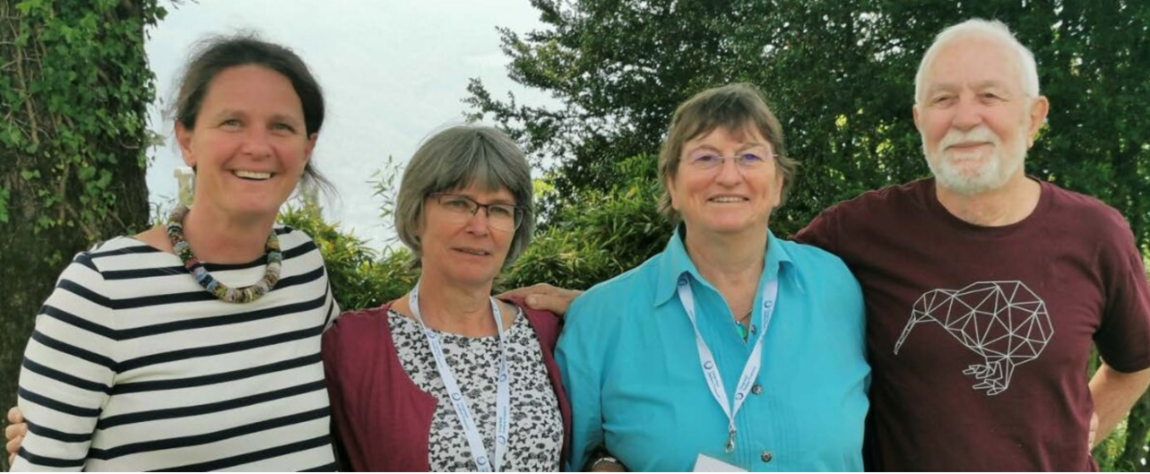
Figure 3. The Organizing Committee of the III International Symposium on Embryonic Diapause. Left to right, Susanne Ulbrich, Katarina Jewgenow, Marilyn Renfree and Bruce Murphy.

References

[1] Fenelon JC, Renfree MB. 2018 The history of the discovery of embryonic diapause in mammals. Biol Reprod. 99:242-251
[2] Enders AC (Ed.) 1963 Delayed Implantation. Chicago, Illinois, U.S.A.: University of Chicago Press
[3] Flint APF, Renfree MB and Weir BJ (Eds.) 1981 Embryonic diapause in mammals. J. Reprod. Fert. Suppl. 29: 260 pp
[4] Tyndale-Biscoe CH, Hinds L. 1981 Hormonal control of the corpus luteum and embryonic diapause in macropodid marsupials. J Reprod Fertil Suppl.;29:111-117.
[5] Martinet L, Allais C, Allain D. 1981 The role of prolactin and LH in luteal function and blastocyst growth in mink (Mustela vison). J Reprod Fertil Suppl.;29:119-130.
[6] Cha J, Sun X, Bartos A, Fenelon J, Lefèvre P, Daikoku T, Shaw G, Maxson R, Murphy BD, Renfree MB and Dey SK. 2013 A new role for muscle segment homeobox genes in mammalian embryonic diapause. Open Biology 3: 130035.
[7] Renfree MB and Fenelon JC. 2017 The enigma of embryonic diapause. Development 144:3199-3210.
[8] Murphy BD. 2020 Under arrest: The embryo in diapause. Dev. Cell 52:139-140

